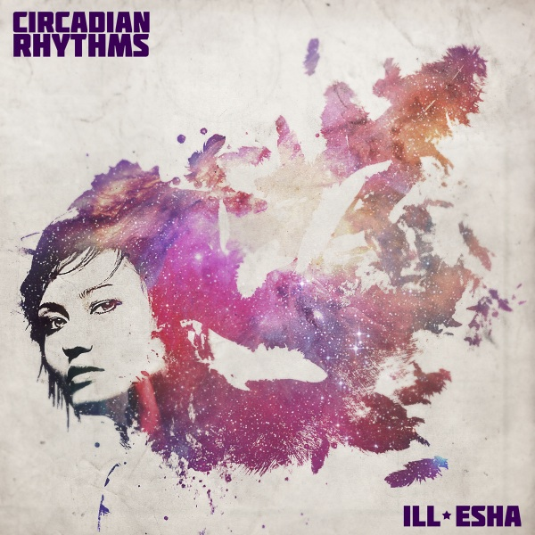

ARTIST: ill-esha
TITLE: Circadian Rhythms
LABEL: Daly City Records
CAT-NO: DCR154
FORMAT: Digital & Special Edition USB Stick w/ Video Content
RELEASE DATE: 11/20/2010
Mastered by: Mochipet
Cover Art: Joyce Su

The debut instrumental album from this West Coast Canadian producer is a myriad of styles and influences reflecting its author's own diverse musical and cultural heritage. With whispers of Latin, jazz, drum & bass, hip hop & techno, ill-esha's meticulously crafted synth work weaves a story within the six dubstep & glitch-hop originals. With over a decade releasing music as a vocalist and producer on labels like Breakbeat Science, BluSaphir, Muti Music and Haunted Audio, the time has come for this prolific artist to step into the spotlight. "Smoke & Mirrors" and "Sullen Sultry" paint lush brushstrokes of sparkles & fireflies, while "Hunting Season" and "Bedbug" showcase a colder, droning soundscape of robot lust. "Cold Hands" and "Stutterfly" are a nod to ill-esha's love of broken beat & nu-jazz, topped off with two bonus remixes from North American up-and-comers Jay Wikid and Ben Samples. Dubbed "crunk'n'B" by Mochipet, it's no wonder this artist is running off her feet balancing remixes with regular appearances on the international tour circuit.

Tracklisting:
01) Smoke & Mirrors
02) Cold Hands
03) Sullen Sultry
04) Hunting Season
05) Bedbug
06) Stutterfly
07) Cold Hands (Jay Wikid Remix)
08) Sullen Sultry (Samples Remix)

Daly City Records, 353 Philip Dr. #306, Daly City, CA 94015, email: info@dalycityrecords.com
Kraddy (Alpha Pup, Muti)
“She's got some great production and is one of the few women I know of making beats!"

Shilo Urban (Dancefever5000)
" ill-esha is one of my favorite producers, DJs and vocalists out there. Her recent mix blew the hinges off my mind & pissed off my neighbors.. holding down the far Pacific Northwest with mountains of bass and a forest of talent"

Sugarpill (Daly City, Glitch.FM)

Ben Samples (Daly City, Muti, Fresh2Death, Denver Bass Squad)
" ill-esha's music just does it for me, she combines the raw power of bass with the sweatiness and sexiness of beautiful melodic leads to make the whole package in dubstep and glitch... and she's the sexiest producer that isn't Ben Samples."

Antiserum (Argon, Narco.HZ, Hollow Point, Subway, Dub Police)
"ill-esha is a musical mastermind. She shines on the mic, keys and in the studio, with a very fine tuned ear for detail. Her productions are oozing with huge melodies and memorable musical parts, interesting progressions, stunning vocals and forward thinking production. ill-esha's music is infectious! you will find yourself humming her melodies on a day to day basis!"

Haunted Audio Recordings (Florida based label)
"ill-esha is one of the hardest working artists in North America. Her musical creations consistantly deliver something different and unique and we are thrilled to have her contributing to our label project"

True Score Theory (North Carolina & California based label)
"ill-esha is the most complete dubstep artist I've heard to date. Melodies soar over churning basslines in a musical voyage of epic proportions. Her live performances are incendiary with sultry live vocals, aggressive mixing, charisma and spotless production blended into a cohesive whole. This album is the culmination of her honing her craft to perfection and will set her apart from the pack in a major way."

Devin Landau (Surefire Agency/Bass Science)
"Circadian Rhythms is Ill-esha's latest mark in time. With precision, she etches her way through soulful soundscapes with a strategic framework of grime and snarl. It is a tight-rope walk on the boundaries of comforting and daunting, making you wish you would rather run into her in a dark alley, rather than on the decks, after her on the line up."

