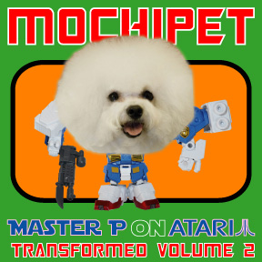
ARTIST: Mochipet
TITLE: Master P on Atari Transformed Volume 2
CAT-NO: DCR150
FORMAT: Digital
RELEASE DATE: 04/06/2010

The release of Master P on Atari Transformed vol1 is a futuristic and glossy rendering of urban club culture throughout the world. Master P vol2 is more subtle, more complex, more contemplative, and yes – weirder. The remixes throughout are clear and brazen renditions of what the artist experiences when sampling Mochipet’s offerings. This release explores the genres of every electronic category known under the sun to bring you a well rounded release; sometimes breaky, sometimes skitzy, sometimes boomy, and sometimes bootie, but always Mochi!!!

*This release also includes complete remix parts for the songs: Marshall Bass Stacks, It Ain't Trickin If Ya Got It, and Godzilla New Year off of Mochipet’s Master P on Atari LP.

Tracklisting:
- Coleco Crunk Vision (Monk Fly Remix)
- Complex Players Dub (LayerZ Remix)
- Robo Crunk Juice (CacheFlowe Remix)
- Complex Players Dub (Ribotto Remix)
- Complex Players Dub (Sugarpill Remix)
- Turbo Thizz Petnation (Mindelixir Remix)
- Pythagorean Hyphy Proof (Bookworm Remix)
- Complex Players Dub (Free The Robots Remix)
- Robo Crunk Juice (Jtonal of The Flying Skulls Remix)
- Ghetto Puddin Pet (Liver Remix)
- Pythagorean Hyphy Proof (Splatinum Remix)
- Turbo Thizz Petnation (Fruitbat Remix)
- Robo Crunk Juice (Encanti Remix)
- Ghetto Puddin Pet (Preshish Moments Remix)
- It Ain't Trickin If Ya Got It (MusSck Remix)
- Ghetto Puddin Pet (Jacob London Remix)
- Remix Parts Marshall Bass Stacks 145BPM Drums
- Remix Parts Marshall Bass Stacks 145BPM Bass
- Remix Parts Marshall Bass Stacks 145BPM FX
- Remix Parts Marshall Bass Stacks 145BPM Vox
- Remix Parts It Ain't Trickin If Ya Got It 150BPM Drums
- Remix Parts It Ain't Trickin If Ya Got It 150BPM Perc
- Remix Parts It Ain't Trickin If Ya Got It 150BPM Bass
- Remix Parts It Ain't Trickin If Ya Got It 150BPM Lead
- Remix Parts Godzilla New Year 90BPM Drums
- Remix Parts Godzilla New Year 90BPM China Sounds
- Remix Parts Godzilla New Year 90BPM Percussion
- Remix Parts Godzilla New Year 90BPM Bassline1
- Remix Parts Godzilla New Year 90BPM Bassline2
- Remix Parts Godzilla New Year 90BPM SoundFX
- Remix Parts Godzilla New Year 90BPM Intro
Monkfly
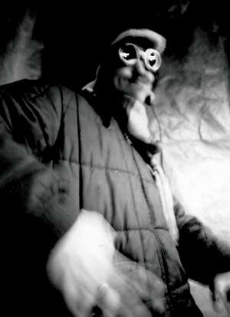
Monk Fly’s debut EP for Daly City Records, Far Side Of Zen dropped in Feb 2010 and hit Addictech's weekly top 10 sellers. Meet the Zen master of jazzy, hip hop and downtempo trip outs. Cleverly crafted chilled out crescendo’s of melodic twangles of dynamic compositions influenced by dubstep, glitch, and wonky beats.

Layerz
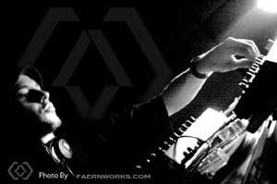
In 2003, Ultra Records nominated Layerz the top finalist for a remix of Sasha’s ‘Wavy Gravy’. Other releases include “Disconnect Yourself” on MDEX Recordings and has more recently released some outstanding Breaks, IDM and Dubstep on Muti Music and the digital album ‘Whispers From ShadowZ’. His style represents an eclecticism of backgrounds: metal bands, IDM, Techno, Psy-Trance, D&B, Breaks, and Electro. Influences range from ‘The Orb’, ‘Nine Inch Nails’, ‘MBM’, and ‘Art of Noise’.
Cacheflow
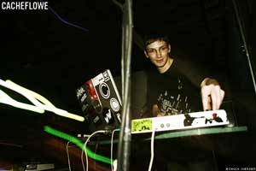

Mashing up idm, hip hop, funk, drum and bass, trip hop, experimental, jazz, techno, dubstep and more. CacheFlowe creates genre-skewing electronic music that has received acclaim from local and international press. Producing with a computer since 1996, he's honed an original style of complex breakbeats, deep analog basslines, techno-flavored synths, organic instrumentation and contorted samples. For more info, visit www.cacheflowe.com

Ribotto


Ribotto’s sound is an electro/acoustic synthesis combining over 15 years of academic institutional piano instruction with psychedelic rock/blues guitar via the modern electronic music apparatus. He is a street performer ventured down from the northwest shore of Lake Superior, Canada.
Sugarpill
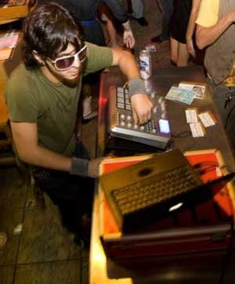
Sugarpill is a Los Angeles based dj/producer specializing in bouncy glitchy bass and experimental noise. His live DJ sets bring an explosive genre bending ruckus to the dance floor and his original productions feature a heavy dose of sample chopping, tweaking and meticulous sound twisting. Sugarpill also writes for abletontweets.com and regularly appears on glitch.fm. sugarpillmusic.com

Mindelixir
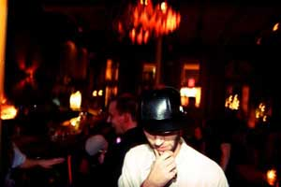
Mindelixir is a bass heavy garage influenced experiment gone off the deep end. He carries the funk of the golden era with the sensibility of a technological singularity occurring. He has recently burned stages playing live alongside the likes of Rusko, Skream, Joker, Benga, Dieselboy, Pretty Lights, and Eliot Lipp. Collaboration and remix projects are in the works for unbelievable artists from the Bronx to Singapore. He puts horse shoes in his dubstep boxing gloves. Watch out.
Bookworm

With a minimalist approach, Bookworm draws you into a syncopated beat driven array of melodic textures and deep bass lines. He blends traditional instrumentation with classic and new school electronic sound design.
Free the Robots
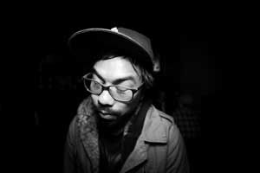
Free the Robots blends futuristic-digital sounds with the classic grittiness of traditional Jazz and Psych. Chris Alfaro of Free the Robots unites an array of vibes creating a sound that draws comparisons to DJ Shadow and RJD2, while also fitting in the same family as Flying Lotus, Nosaj Thing, Daedelus and the entire Los Angeles movement. Dirty drums, heavy bass, and haunting melodies progress throughout his songs in a unique style that can connect the past, present, and future.

Jtonal of The Flying Skulls
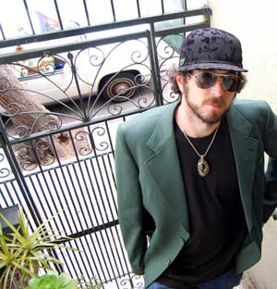
J. Tonal founded Lowpro Lounge Recordings in 1999. The Flying Skulls have released albums on 1320Records, Daly City Records, Lowpro Lounge Recordings, and Addictech. As a DJ and live set performer - J.Tonal has shared billing with musicians such as DJ Shadow, DJ Krush, Les Claypool, Prefuse 73, Ghostland Observatory, STS9, Bassnectar, The Glitch Mob, Shpongle, Ott, Jack Dangers, Lotus, Amon Tobin, Pretty Lights, and UFO!

Liver
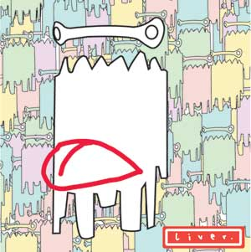
Liver: Spawned from the mucus that created life on earth, Liver rose from the South of the world to torment the bass heads. South African born and bred, he producers at all tempos and has played all over SA! So come on... put on your bassface!

Splatinum
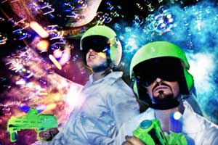
SPLATINUM is the collaboration of Andrew Luck and Adam Houghton aka. Dosadi. “Luck and Dosadi’s rhythms and bass frequencies slug and surge with a thrilling high impact.” “Every sound seems to be massaged extensively and genetically tweaked to maximize grimy bling-osity, coating the tracks in high-gloss soot” – Dave Segal, The Stranger

Fruitbat

Tha Fruitbat is a nocturnal vegetarian that comes from the tropics using an interpreter and some electronic gadgets converting sonar into music.

Encanti

Ben Cantil AKA Encanti produces high-energy electronic music with the Vermin Street crew in Boston, Massachusetts. Creating all varieties of heavy and bassy dance floor experiences, Encanti performances often feature rich visuals in the audo/video project Zebbler Encanti Experience, with HD video by Zebbler. ::: http://www.encantimusic.com/ ::: & ::: http://www.zebblerencantiexperience.com/
Preshish Moments
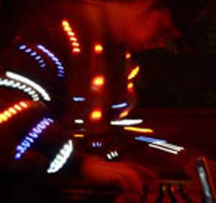
Preshish Moments makes electronic music, builds instruments, programs patches, sews LED suits and plays live instead of pretending to play live. He programs, build electronics and created his own midi controller named Splinter. He used them buy to win a laptop battle, play around the world, and release a solo album and several remixes for alternate artists. The latest addition to his mayhem is the creation of a suit that flashes red, white and blue LED’s in time with his music. Check it out: www.preshishmoments.com

MusSck
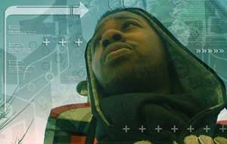
MusSk has created an ecosphere of sounds inside his beats the reflect the beauty of the intricate design of nature. He uses an array of sounds with mirco samples and edited beats to include visions of his art.
Jacob London
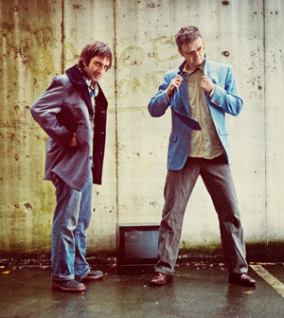

Jacob London has releases/remixes on Om Records (San Francisco), .dotbleep (Chicago), Doubledown (San Diego), U-Freqs (UK), and Derrick Carter & Luke Solomon's enormously popular Classic Records (UK) imprint. "Jacob London" has become a household name for house and techno dj's all over the planet.

