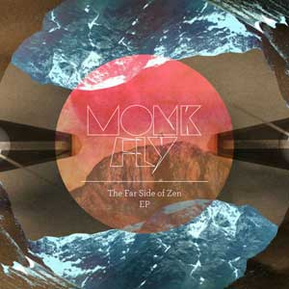
ARTIST: Monk Fly
TITLE: The Far Side of Zen
LABEL: Daly City Records
CAT-NO: DCR146
FORMAT: Digital
RELEASE DATE: 02/02/2010

Tracklisting:
01) Birthday Funk
02) Hurry Chops
03) Ghlomp
04) Well If I Ever!
05) Bumpin Joints

Remember back to your first ever party with hormones and expectations coursing throughout your charged and electrified body – Sydney, Australia based DJ/ Producer and Radio Show Host with a love and appreciation for abstract, fat future beats,
MONK FLY is the man to take you back to that wondrous time and place again on his first release for Mochipet’s Daly City Records, The Far Side of Zen.

Monk Fly epitomizes the essence of the NOW with his whompy, skitzed out beats.
This is dubstep without so much of the dub. His approach takes the beats along what you think is a standard path and then he laughs when you jump at the glitch and wriggle when he provides the infrastructure for the rest of the record.
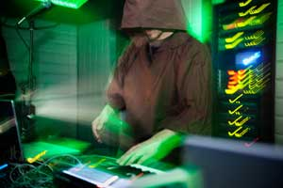

Monk Fly is a Producer, Dj and musician influenced by jazz, hip
hop, dubstep, jungle, wonky beats & the found sounds of his
environment.The Monk Fly sound is thus animated, diverse, bass
heavy and has ended up in the record bags of some of the worlds
most respected DJ & Producer such as Danny Breaks (UK),
Flying Lotus (US) & Gas Lamp Killer (US).
Monk Fly’s previous releases through his own label,
The Frequency Lab, have had critics stating:
“...serious top notch production…fusing together a variety of
musical inspirations. I’ll eat my hat if you don’t appreciate this”
(3D world) “a stand out Sydney producer…” (www.inthemix.com.au)
Live Monk Fly cuts both an amazing laptop set or DJ set. A recent
2 part live laptop set can be heard or downloaded at
www.fortheheads.blogspot.com
Live reviews have commented, “see this lad he has an ear for
sound and where it meets fun...he rocked” (Drum Media)
Most recently Monk Fly has played support to Internationals
such as Hudson Mohawke, Mamiko, Harmonic 313, Deadbeat,
Benga, Skream & Dorian Concept.
Monk Fly, with his cohort Jonny Faith, also hosts Sydney’s only
weekly future beats radio show (FOR THE HEADS) and also the
only regular club night HEADROOM dedicated to such left-field
wonky beats, Beyond producing, Monk Fly has long been an active player
in the Australian music scene. He was a founding member of
Elefant Traks, a label now known for “...some of Australia’s
best hip hop, dub and broken beats.” (Juice Magazine)
After Elefant Traks, Monk Fly continued on to set up The
Frequency Lab, an artist run initiative - offering affordable
performance, recording and exhibiting space. The Frequency
Lab ran for 5 years as a venue and became known as “the
breeding ground for Sydney’s creative music community.”
(Clayton Thomas, co-director of The Now Now Festival). The
Frequency Lab has since evolved into one of Australia’s most
innovative boutique left-field music labels.

FLIGHTS:
The Hi Fi Club (UK)
The Faversham (UK)
Couch Bar (UK)
Bist rot reque (UK)
St George's Theat re (UK)
Schokoladen Bar (Ber l in)
Trodler (Ber l in)
Underbel ly Fest ival
Peats Ridge Fest ival 06,07,09
The Great Escape Fest ival
Woodford Folk Fest ival (Br is)
Chalk The Walk Fest ival
Ear thdance Fest ival
Playground Weekender Fest ival
The Sl ip Inn
The Gael ic Club
Hermanns
Bar Broadway
The Abercrombie Hotel
The Mandar in Club
TINA (Newcast le)
Pony Bar (Melb)
Loop Bar (Melb)
The Gl i tch Bar (Melb)
Bar Open (Melb)
Revolver (Melb)

RESIDENCIES:
Cafe 1001 (UK)
The Cr icketers Arms
The Clai re Hotel
The Frequency Lab/ Knot Gal lery
Lab Styles @ The Excelsior Ht
The Lounge Cafe
Headroom @ The Br ighton Up Bar
For The Heads - 2SER 107.3 FM

