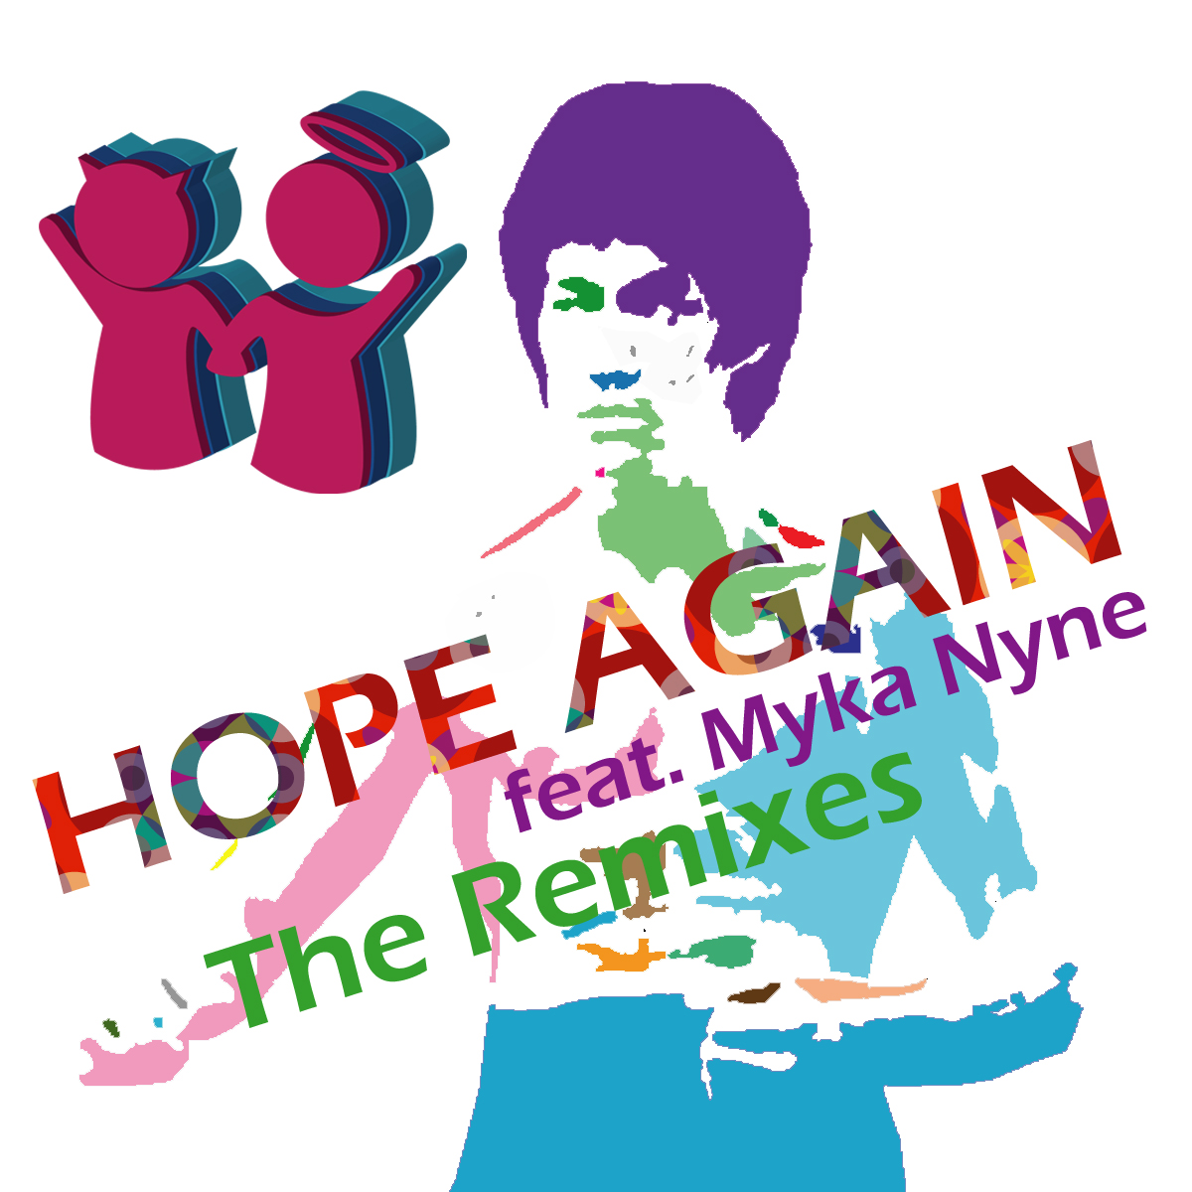

ARTIST: Mochipet and Myka Nyne
TITLE: Hope Again (The Remixes)
CAT-NO: DCR132
FORMAT: Digital
RELEASE DATE: 10/07/2008

“Hope Again,” the classic track from the first Daly City Records Compilation “Baby Godzilla“ (2006) has just been Re-glitched, re-funked, scratched, warped, and dancehall-ed! When Mochipet teamed up with legendary MC Myka Nyne (Freestyle Fellowships) to make a brand new style of Hip Hop back in 2006 no one knew it would take such precedence today. So much so, that it has warranted remixes by: Lille France’s Glitch Hopper Deework (Think Prefuse meets Autechre), and San Francisco’s Bhangra Dub master Kush Arora, and the sensual melodies of Commute. We see the many monikers of Bill Mitsakos, Spaceheater, Vladimir Computin, and here Many Illz with Sho Fo. But it doesn’t stop there. Eriksolo of the Meanist Man Contest comes correct with a shuffle monster featuring scratches by DJ Cheapshot of Styles of Beyond and Fort Minor. Yoko Solo Bangs it out with force and massive bass, while Oakland’s Build128 shows that there could indeed be a marriage between Flying Lotus and Venetian Snares. Last but not least Taiwankid brings us a dancehall tech beat that will make you put up your lasers until the pokemons come home.

Tracklisting:
Hope Again (Deework Remix V2_29)
Hope Again (Kush Arora Remix Featuring The Genie)
Hope Again (Comute Remix)
Hope Again (Many Illz Remix Featuring Sho Fo)
Hope Again (Eriksolo Remix Feat DJ Cheapshot of Fort Minor and Styles of Beyond)
Hope Again (Yoko Solo Remix)
Hope Again (Build128 Remix)
Hope Again (Taiwankid Betelnut Dancehall Mix)

