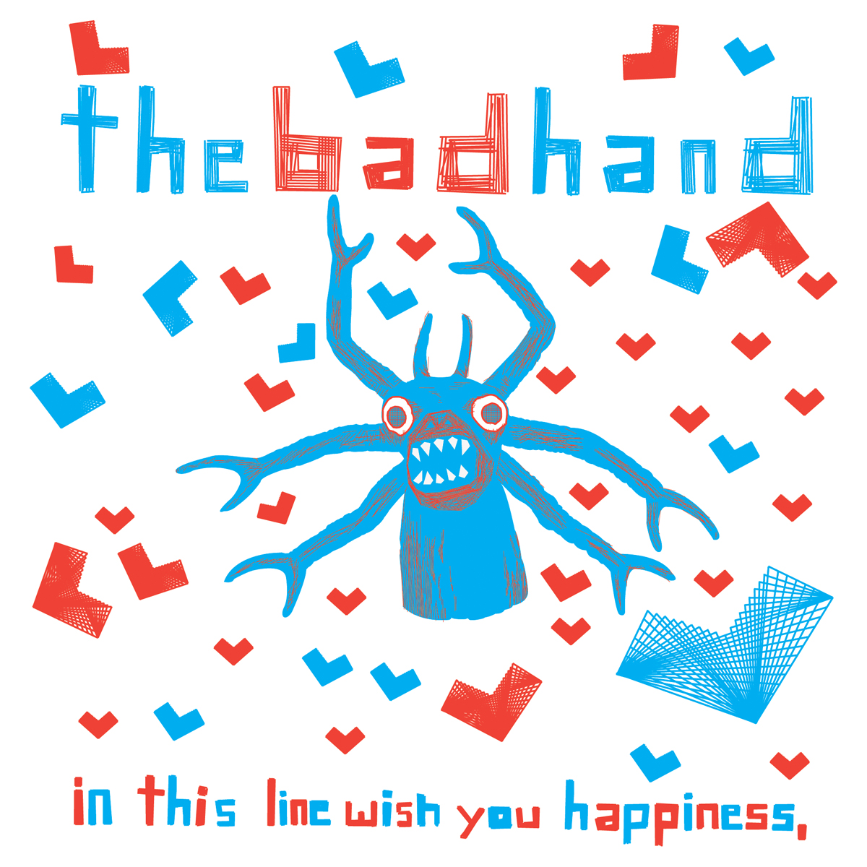

ARTIST: The Bad Hand
TITLE: in this line wish you happiness,
LABEL: Daly City Records
CAT-NO: DCR131
FORMAT: CD
RELEASE DATE: 10/28/2008

From the opening barrage of feedback to the penultimate banjo solo, The Bad Hand's new EP, "in this line wish you happiness," is full of surprises. The San Francisco trio (Dan Brennan, Tim Pizza and Matthew Zipkin) mostly play drums, guitar and Rhodes piano respectively, but all bets are off as to what instruments or other debris they'll throw into the mix, especially now that they're building their own instruments...most notably the Verb-O-Matic and Imipolex G (as seen on YouTube). Unencumbered by a lead singer, The Bad Hand lets each song do its own talking; their music resembles not so much a conversation as a heated discussion. Reviews of The Bad Hand's debut LP, This Is No Time For Modesty, likened the band to both Guided By Voices and Dave Brubeck. SF Weekly called them "noiseniks," which The Bad Hand took as a compliment.

"Malcontent party music." - MidwestRecord.com

"A band to look out for." - Record Collector UK

"Noisy post-punk extravaganza." - Smother.net

"Avant garde fuzz heavy punk licks with
frenetic rhythms and sudden jazzy ejaculations..." - Music Morsels

Tracklisting:
01) Your Smell is Your Name
02) ?doG eeS eseeG oD
03) Ruinous Fleshpetal Secrets
04) First "That Song," then "Lo Ha," now this…
05) Pls Answer Ur Phone
06) MDI2

Daly City Records, 353 Philip Dr. #306, Daly City, CA 94015, email: info@dalycityrecords.com

