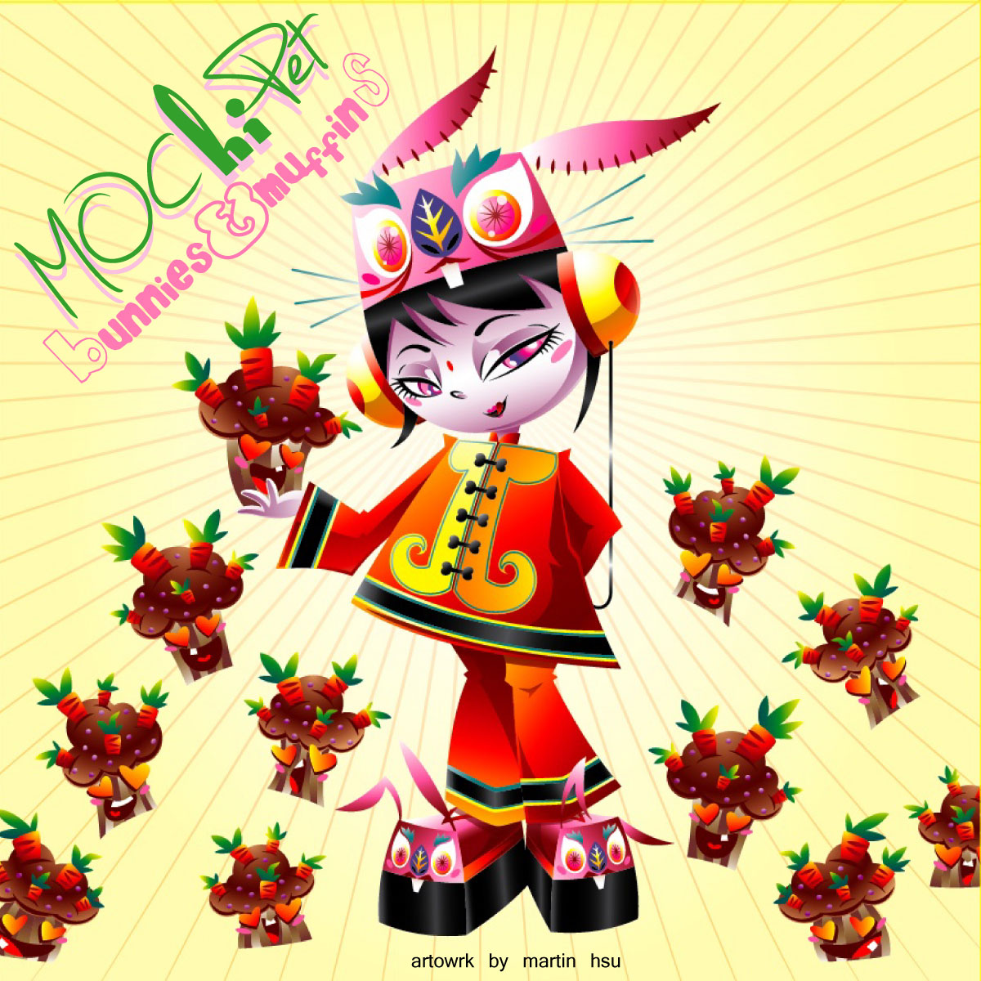

ARTIST: Mochipet
TITLE: Bunnies and Muffins
CAT-NO: DCR129
FORMAT: Digital & Special Edition CDs
RELEASE DATE: 03/03/2009
ARTWORK BY: Martin Hsu (martinhsu.com)

Hot off the heels of Mochipet’s “Microphonepet” banger which gained him a spot on NBA2k9 Videogame along side acts such as Beastie Boys, N.E.R.D., and The Cool Kids, comes a more melodic and subtle record. Cozy enough for an afternoon stroll but still intricate enough for any hard core music aficionado. Bunnies & Muffins bounces you all the way from glitch-hop to symphonies. Tracks like “Prolonging Forever” and “Fool” Bring elements of Ratatat and Prefuse73 with a more harmonic organic feeling. While “Anthem” bangs you over the head like a Bon Jovi on Kraftwerk.. Tracks from this album are surely going to add Mochipet’s appearances to more Movie Soundtracks, and Radio Playlists. There might be a reason why he was nomited as one of the Best Electronic Act of 2008 by many publications such as The Clash Magazine (UK), Bay Guardian, and The SFWeekly. Kid Koala – “Mochipet is hilariously funky, he should score the next Katamari video game, you can quote me on that. :) e”

Tracklisting:
01) Anthem
02) Spring (Featuring Daedelus)
03) Prolonging Forever
04) Memories
05) Pachyderm Pounce
06) Fool (Featuring Spaceheater)
07) Underwater Aardvark B-Boy Beats (Featuring Roman Ruins)
08) Do Geese See God?
09) And So It Goes…
10) The Erhu Song
11) End of Summer Song
12) Oly
13) Tinker (Featuring Aeroc)
14) Roll Credits

Daly City Records, 353 Philip Dr. #306, Daly City, CA 94015, email: info@dalycityrecords.com

