Preshish Moments – “Let’s be Friends”
Label: Daly City Records
Catalog No: DCR-128
Release Date: July 11, 2008

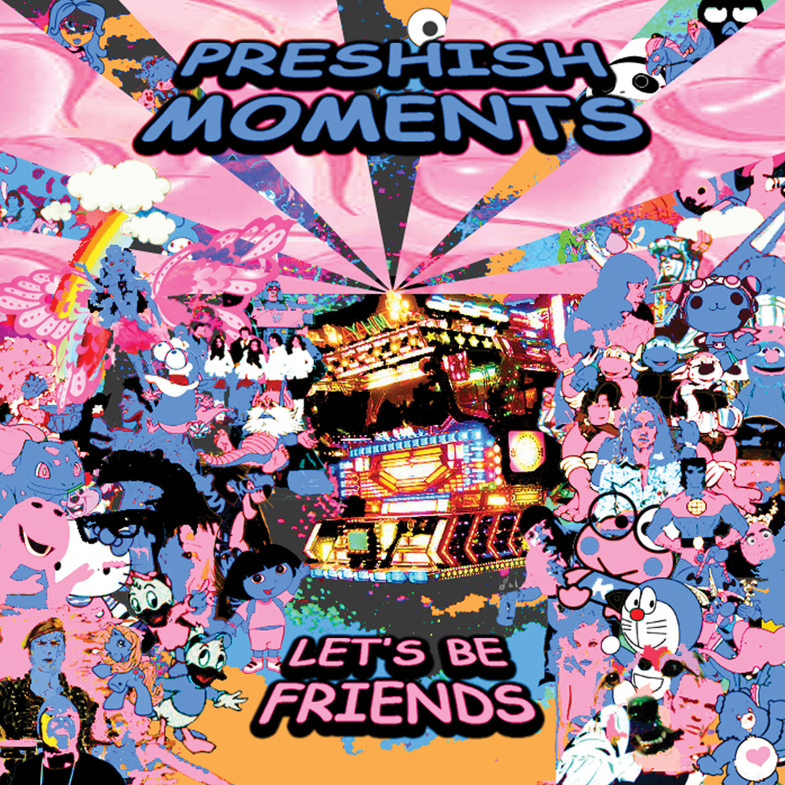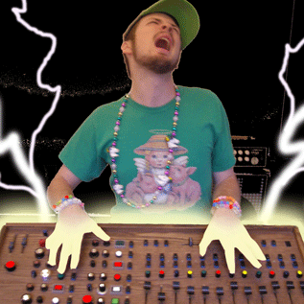

Preshish Moments is the cuddly demon-seed of Michael Carter and the 2007 winner of the San Francisco Laptop & Machine Music Battle. Hailing from Berkeley, CA, Preshish Moments builds unique instruments for the performance of electronic music.

“Let’s be Friends” is Preshish’s debut album. It devours hip-hop, house, jungle, pop, rock, hardcore, breakcore n’ more, and vomits out a rainbow of offbeat melodies and skittering drums. It features several smash hits such as “Best Friends” and “Hollaaaaaa”.

Visit http://www.preshishmoments.com for more info.

Available on CD from Daly City Records http://www.dalycityrecords.com
Daly City Records
353 Phillip Dr. #306
Daly City, CA 94015

