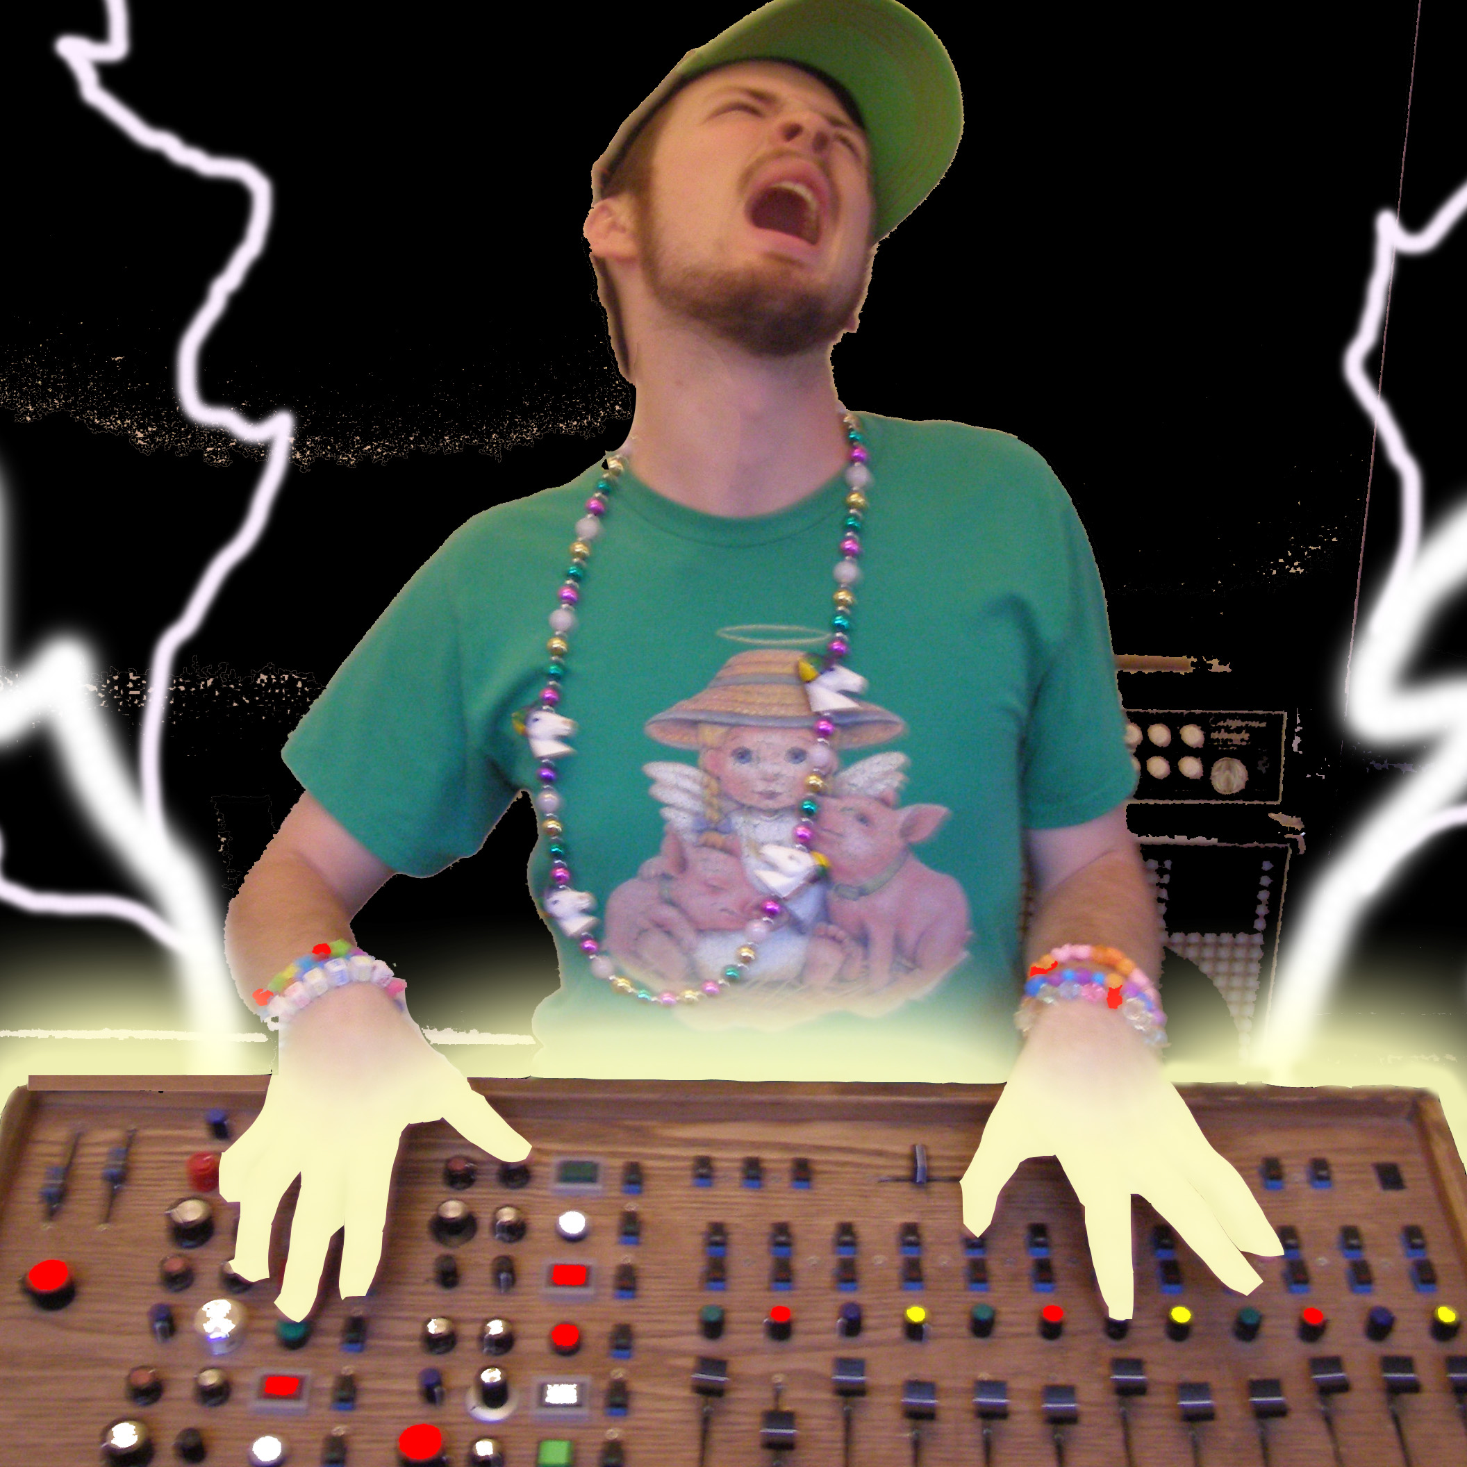 Bio of Preshish Moments

Preshish Moments is the moniker of twenty-six year old Michael Carter. He makes electronic music and builds unique instruments for live performance. In 2007 he used one of these instruments to win the San Francisco Laptop & Machine Music Battle, competing against over fifty contestants. His debut album “Let’s be Friends” is set to come out on Daly City Records on July 1st 2008 and he can often be heard performing in and around the San Francisco Bay Area at a wide variety of venues playing an even wider variety of styles.
Raised in a suburb of Los Angeles (and former home of the Carpenters), he played clarinet as a child and became obsessed with spinning records and the art of sampling as a teen. He learned how to spin hip-hop and jungle by closely studying flourishing local hip-hop and rave scenes.
He moved to Chicago in 2000 to attend the School of the Art Institute of Chicago for painting, but quickly changed his focus to sound design. He learned more about electronics and audio engineering and became interested in creating new ways to play electronic music. This was also where he discovered the music of Aphex Twin, Venetian Snares, Squarepusher, and countless other electronic musicians who pushed the boundaries of dance music.
In 2005 he moved to Oakland to pursue a Masters Degree in Electronic Music and Recording Media at Mills College and it was here that he finally built and began to perform with the instrument of his dreams. He uses it to play house, noise, hip-hop, dubstep, jungle, hardcore, breakcore, drone, free improv, cyber-boogie, metal, pop, wedding music, chant-rock, and pre-preshcore. He also likes to bake.

