

ARTIST: Mochipet
TITLE: Feel My China II
CAT-NO: DCR124
FORMAT: CD
RELEASE DATE: 03/11/2008

Following “Feel My China I” featuring remixes by Drop The Lime, Jason Forest, Devnull, Skymall, Exillon, Duran Duran Duran, among others, Feel My China II is a deeper exploration into the world that is called “Mochipet.” Laced with heavy hitters like: Edit, dDamage, [a]pendics shuffle, Geoff White, Machine Drum, the disc explores the genres of Glitch Hop, Electro, Techno, IDM, Breakcore, Ambient, and every other electronic category known under the sun to bring you a well rounded release all in a nice little rice dessert package; sometimes breaky, sometimes skitzy, sometimes boomy, and sometimes bootie, but always Mochi!

Track Listing:
01) eDIT Nanu Crunkster Machster Mix
02) dDamage Justin Timberlake in Paris Core
03) Capt. Scarlett Just Mochi (Remix Winner)
04) Yoko Solo Grab Your Mochi Junk Remix
05) Kat5 Bloody Desert Baklava For Oil Mix
06) Aneurysm Epic Baklava
07) Komori My Emo Robot Girl Remix
08) Droid Behavior MochiGrind
09) Kenneth Gibson 8fm vs. [a]pendics shuffle’s Saxual Chocolate Mix
10) Cardopusher Dark Side of the Pencil Box Mix
11) Eustachian Flamenco Essay Con Frito Remix
12) Plankton Man Mexican Pencil Box Mix
13) Machine Drum African Trampoline Mix
14) Kero Detroit Mochi Cake Mix
15) Geoff White / Aeroc Three Cheers for Mochi Mix
16) Many Illz Dorboro Dojo
17) Dino Felipe Mochi Just Mochi (We’re Always Here Mix)
18) Bloodysnowman Bloodymochimix
19) Solypsis Disco Moliere
20) Branscratch Kira Hammond Mix

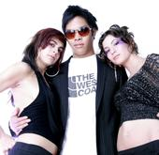
eDIT (alphapup)
Born and bred in Weston, Massachussetts, Edward Ma, now known to the world as edIT, began his music career as "The Con Artist" just before the turn of the millennium. As a resident DJ at the now defunct Konkrete Jungle Los Angeles, he shared the stage with Hive, Daddy Kev, James Tai and mic rockers Busdriver, P.E.A.C.E. and Mikah 9. Konkrete Jungle marked the golden age of indie hip-hop in Los Angeles, and was the bridge between the jungle and b-boy massives.

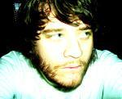
Kenneth James Gibson (kompakt/adjunct)
AKA. Kenneth James G. / [a]pendics.shuffle / Eight Frozen Modules / K.J. Gibbs / The Premature Wig / dubLoner / Bal Cath / Electronic Music Composer / Reverse Commuter / Hiss and Buzz Kenneth James Gibson is a man of many personas. Keeping up with him can be a time consuming, yet rewarding venture into sound. As soon as you think you know him and can grasp whats going on, he puts on yet another mask and becomes something else. Always a surprise and never a let down, he gives us what we want but dont expect. A rare stone in todays musical climate, Ken is rolling and collects no moss.--

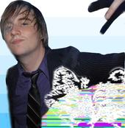
Machine Drum (merck/normrex)
I am a 25 year old Producer/Instrumentalist/Artist from Hickory, North Carolina. I currently reside in the Bedford Stuyvesant area of Brooklyn, New York. I have been making electronic music since I was 12 and have been playing the guitar, piano, drums, bass and various other instruments since I was 6. I have released albums as Machinedrum, Tstewart and Syndrone on Merck Records out of Miami, FL. I plan on releasing my upcoming album "Want to 1 2?" on the new New York/LA based label Normrex. Below are some of my other projects. Click on the pic to go to its corresponding reference page. Thanks for visiting. I love you.

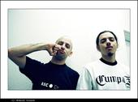
dDamage (tigerbeat6)
dDamage is a duet driven by two brothers. Since the year 2000, they released several records on some french, swiss, austrian and japanese independent labels. They also released a lot of tracks on various compilations (Active Suspension, Angelika Koehlermann, V/vm Test Records, Tsunami-Addiction, Ronda Records, Planet-Mu) They play a very energic electronic music, with some hip-hop influences, churning wild guitar riffs, furious samples and analogical synth noises.
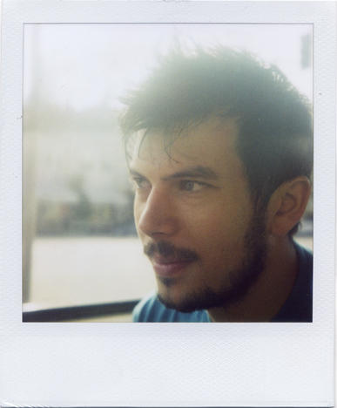
Many Illz (a.k.a. bill mitsakos) is a DJ, producer, and music
technology mastermind. He is the production force behind San
Francisco glitch-jazz ensemble "Spaceheater" and has remixed and
collaborated with the likes of UFO!, Edit, Photek, Sts9, Mochipet,
Daedelus, and many more. He is presently residing in Auckland, New
Zealand where he designs kick ass software and hardware for Serato
Audio Research. Tune in to his weekly radio show at basefm.co.nz.

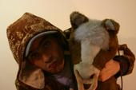
Komori
Komori has been weaving iridescent melodies for almost ten years, ambidextrously shuffling sampler breaks, groovebox acid, indie-rock noise on the electric guitar and analogical synthesizer frequencies... fuelled by a passionate following of musical pioneers such as Autechre, Run Dmc, Dinosaur Jr.,

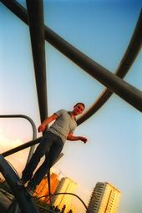
Geoff White / Aeroc (ghostly)
From Geoff Quote: “how's this for your one-sheet? ... "geoff is a fucker. he occasionally makes twisted music that he greedily hordes to himself as a court-appointed rehabilitation regiment. this track escaped the wretched hands of the police to land on a bizarre compilation with chinese implications. this could land him another few years punishment but there's comfort in the fact that he really doesn't care."

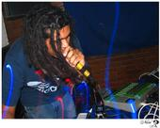
Cardopusher (peaceoff)
Cardopusher has expanded the limits of his hypernoisecore to its logical extremes, busting through genre barriers and demolishing everything in his path. Extreme pop and extreme noise go head to head in the raved-up dancehall with gloriously messy results. You can't afford to miss a second cause it doesn't get more intense than this." - Kid Kameleon (XLR8R Magazine)

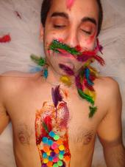
Dino Felipe (schematic)
dino felipe first started releasing "noise" casettes using his 4track in 1998 on labels such as public eyesore,and white tapes,and spite from NY...his 4track brke and he financed a gateway and began trying to learn to use it around 2000...after tedious times from switching to 4track anti-computer mentality to computer friendly,he has then released albums on labels such as:schematic,dulcett records,rolax and sublight.dino's music STILL tends to have obvious influences of electronic no-wave,and deconstructive electronics for lack of better words.
although using a PC now,you can still hear his past influences bleeding through the wave files as opposed to 4track master casettes...his music has recently been called "broken electronica"...what does he think about that
genre?..."i dont care what they call it."
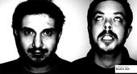
Eustachian (fathme)
Eustachian's live acts have shocked and awed crowds the world over. Both John and Anthony quickly started touring around the USA and touring abroad in Europe with acts such as Machindrum in 2004 and Vytear in 2007. After returning from their successful European tours they released on various labels, such as Dalycity, Component, Merck, V135, Militia, Noize:tek, Puzzex, and finally their own newly created Neo Psych Horror-core Label called Fathme. Eustachian will be adventuring on a Alaskan tour in late December 2007, and a upcoming 2008 Europe tour with UK based artist The Teknoist.


Plankton Man (run recordings)
PLANKTON MAN plays with traditional/popular Mexican music such as the brass heavy BANDA, accordeon accents, cowbells of NORTEÑO music, and reconfiguring it to create a fresh mood. This mixture of Mexican traditional folk sounds, breaks and freewheeling jazzy riffs quickly became one of his signature sounds. Parallel to this project; He is part of Niño Astronauta . As innovative as any of his other musical ventures, this project brings a musical offering that is as original as it is challenging -- A LIVE "nortec" electronic act that takes the genre to the next level. Nashio is also 1/2 of the duo "Kobol" , along side Arhkota. Their sound is a mixture of organic glitch and digital jazz played live with guitar, drum pads and a laptop.
-By Boro

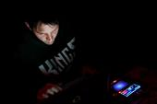
Yoko Solo (quaketrap)
"The Beeps mates wikky wikky turntablism with various off-beat skitters, shuffles, wailing squelches and tasteful breaks to keep your head in the game. An experimental challenge worth taking on."
Jen Boyles, URB

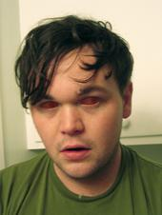
Bloodysnowman (Daly City/Mathlab)
nova. they don't have sharks. but they know alot about planets and other stuff you probably don't care about. that's ok. they don't care about you either. I wonder if nova has deleted my friendness yet. it is too painfull to check. if you are out there nova.......thanks for the spaceship you sent me for my spring break/ birthday party (sponserd by sparx). and the lifetime supply of awsome. pbs would be bullshit without you nova. if pbs ever raises a hand to you nova I will XXXXing Xill them.

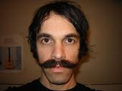
Aneurysm (tigerbeat6/switchcraft)
Aneurysm is not affiliated with any sect, denomination or DJ Krew.
For a 6 year old discography and free downloadable music, please visit: www.switchcraft.org

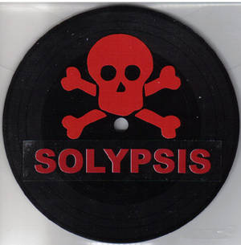
Solypsis
"Solypsis has successfully weaseled his way onto dozens of compilations alongside major electronic artists although he lacks even the most rudimentary musical skills. He also started the Digital Vomit record label for shits and giggles."


KatFive
CatFive is a laptop-based music production group based in Oakland, CA formed in the latter half of 1999. Their debut album, Kataphonics, was released in 2001 on Hip Hop Slam records. Their most current release "Big Brother Runs The Company" is available as a free download on their website at www.katfive.com.
The original line-up consisted of DJ Darkat, Balanceman, Tweaktech and Dr. Oliver Klosvoff while maintaining that the mysterious fifth member of the band was the Cat. Subsequently, they were joined by DJ Earflaps and went on to play live shows in the bay area and beyond.


Brainscratch
For kira creating dynamic and unique electronic music is a passion. Her favorite activity is crafting soundscapes into musical movements. Kira launched Laoco in 2007 to release music by her collaborators and friends, check out www.laoco.net and buy the trax through iTunes. Currently 3 albums are available by choenyi, Orange Core and Kira. You can also find kira's music online at www.myspace.com/kiraofthewired Thanks for listening!

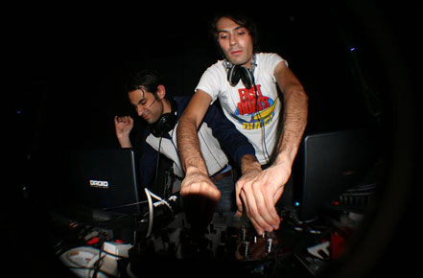
Droid Behavior
Acid Circus is comprised of brothers Vangelis and Vidal Vargas.
In an industry where DJ's no longer dominate the action with pressed
wax, live PAs have taken digital mixing to another level. No strangers
to tweaking and freqing everything within ear shot, over the last 5
years the members of acid circus have constantly displayed the art of
techno live performance. Dropping tracks, remixes, samples, mashups,
left hooks, and techno grime in and out of the mix has become an
ultimate trip in pure crowd reaction at LA undergrounds.

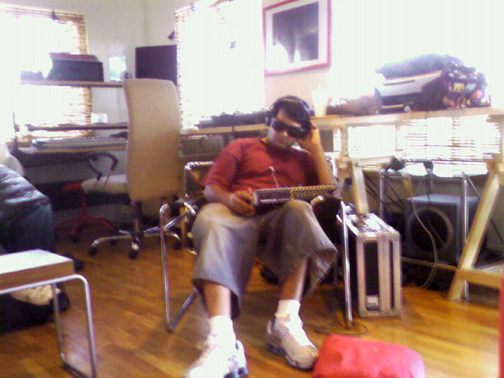
Kero
With over 20 releases on some of electronic music’s most celebrated and innovative labels such as Bpitch, Ghostly International and Shitkatapult and most recently Downwards as well as his own critically acclaimed Detroit Underground Records, Kero (nee Sohail Azad) has established a reputation for his unrepentantly brash, yet cultivated compositions and unforgettable live performances, most recently, alongside notables such as Speedy J, Ken Ishii and Funkstorung. Furthermore, he has established himself as a leader within the growing pack of electronic music producers successfully infiltrating contemporary art circles world wide.

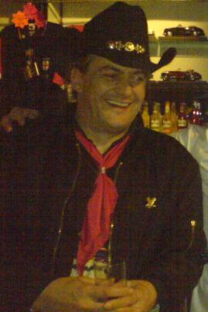
Cpt. Scarlett (Remix Contest Winner)
Born in Manchester U.K., John (a.k.a. Cpt. Scarlett) did not get a taste for performing live until the age of 17, when he began trying out allsorts of acts from magician to stand-up comedy but could find nothing that was really comfortable until he tried DJing at public parties and hotels in Blackpool U.K. this became his driving force. Firstly playing with hired decks and cheap lighting effects, John constantly strove to find ways of improving performance and crowd enjoyment.

