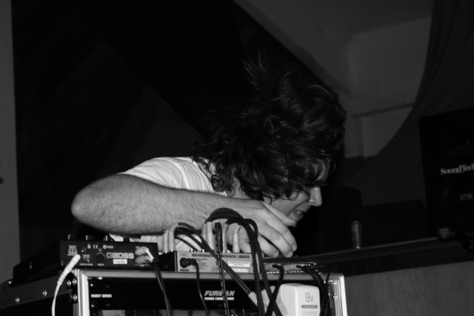
BlipVert
BlipVert is the moniker of composer/multi-instrumentalist Will
Redmond. BlipVert came to the forefront of Will's identity in a small
room above an animal hospital in the winter of 2001.

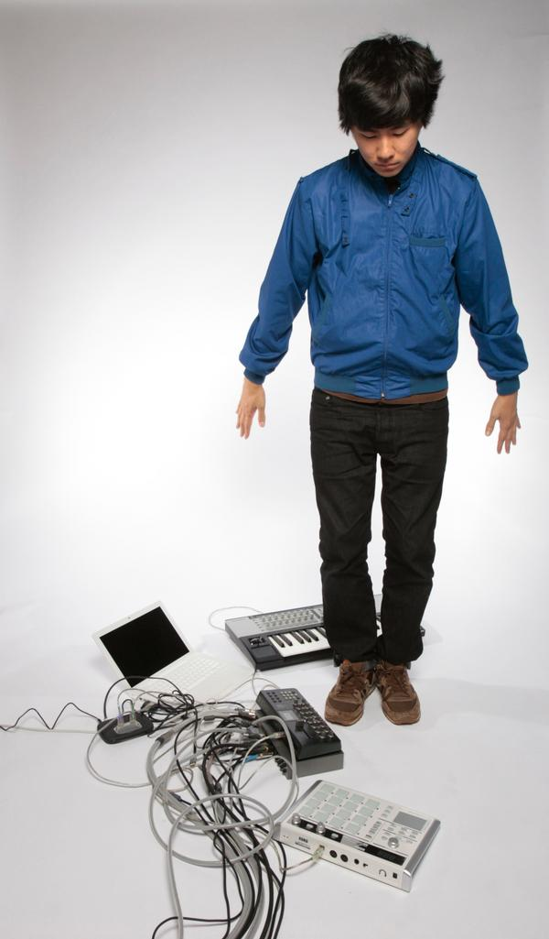
Nosaj Thing
Nosaj Thing has received Artist-to-Watch accolades from XLR8R, remixed Daedulus and Elliot Lipp, won Plastic Little/Turntable Lab's remix contest featuring MF Doom, and won L.A.'s prestigious Project Blowed beat battle. He has shared the stage with the likes of Sixtoo, Architecture in Helsinki, DJ Krush, Z-Trip, Free the Robots, Eliott Lipp, D-Styles, Edit, and Daedelus. He's a staple and a crowd pleaser at L.A.'s underground hip-hop good time, Low End Theory. Comparisons run along with Ratatat, DJ Shadow, and Boards of Canada. A survey of his own record collection will turn up pieces from Aphex Twin, Stereolab, Radiohead, Daft Punk and Eric Satie. In so little time, he's accomplished so much. With his first full-length in the works, be prepared to hear a lot more noise from Nosaj Thing.

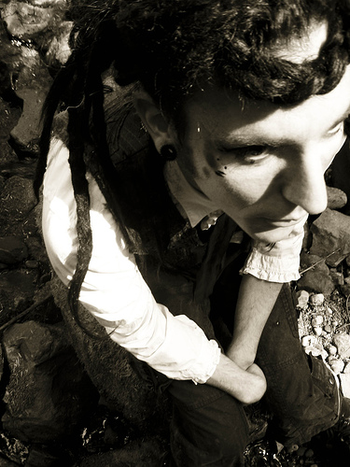
Nezzy Idy
Based in Oakland, California, Nezzy Idy is a memetic vehicle for independent multi-media artist Emit Idy. Fascinated with fairy tales and psychedelic culture, Emit strives to make ambient music and video art which conveys multidimensionality and timelessness. Nezzy Idy cordially invites you to watch as a myriad of colors coalesce and synthesize into dreams and hidden worlds. Emit has a bachelor's degree in sound arts and currently works as an engineer at an audio post-production facility in San Francisco, California. His private music studio lives atop a tower hidden away within the steel walls of the Katabatik Compound. Visit http://www.katabatik.org/nezzyidy
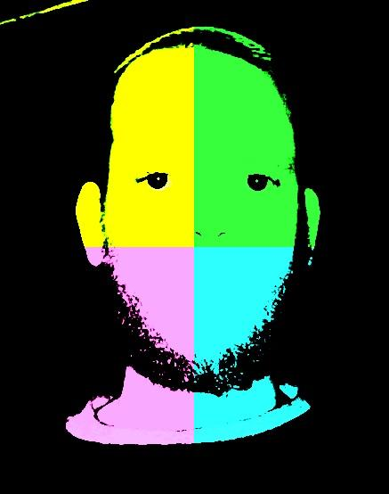
MattyBoJangles
Born and raised in Hayward, California, Matthew "MattyBoJangles" Logan has redefined music for the lesser part of the area in his home, with occasional tom-foolery with the Circuitry crew. Working from a hi-tech, 3 year old laptop in his livingroom, he weaves together intricate collages of sound that can only be described as "well, this would be good for a soundrack to a strange movie". He prefers to call it "brainfart music". Creating a web of fractured beat and not-all-there melodies and/or noise from various sampled sounds, including but not limited to his son's rantings, his wife washing dishes, various re-purposed toys, and other day to day things, MattyBoJangles makes weird beats that only a mechanical engineer/husband/father/brother/son/friend/loser/winner/Earth citizen could make.
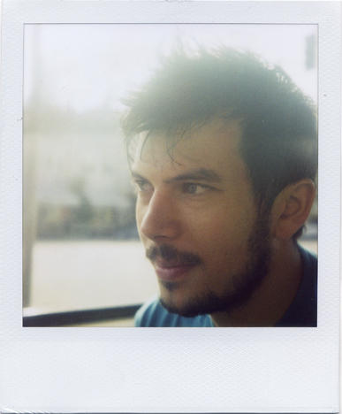
Many IIz
Many Illz (a.k.a. bill mitsakos) is a DJ, producer, and music
technology mastermind. He is the production force behind San
Francisco glitch-jazz ensemble "Spaceheater" and has remixed and
collaborated with the likes of UFO!, Edit, Photek, Sts9, Mochipet,
Daedelus, and many more. He is presently residing in Auckland, New
Zealand where he designs kick ass software and hardware for Serato
Audio Research. Tune in to his weekly radio show at basefm.co.nz.
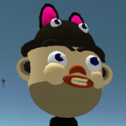
Darkat
is the assumed name of Oakland based audio visual artist Ezra Li Eismont. Both a fine artist and musical producer, Ezra began his musical career with the 2001 release of "kataphonics", the debut album by Oakland based experimental sound artists "CatFive", a group he started with fellow musician and co-conspirator Jeremy Goody, aka "Balanceman". 2006 saw his first solo release, a 6 song 12" E.P. title "Omnia Ab Uno" released on Nutmeats records. Darkat on myspace: http://www.myspace.com/darkat

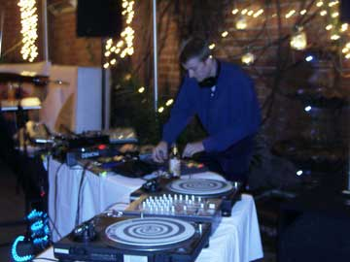
Cypod
Academically trained and street tested in the ways of beatmaking,
Cypod has transformed through many mediums and spaces. From the
concert hall, forest, cafe, mp3 player, computer, and beyond.

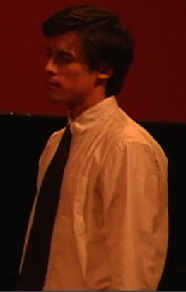
Laskfar Vortok
is a co-founder of the Naboamusic net-label in San Francisco; an independent platform specializing in releasing experimental electronic music with a healthy and heavy emphasis on idm, glitch, hardcore, breakcore, techno, ghetto-tech and noise. He also releases music under the Naboa moniker when collaborating with fellow artist EDN. Throughout his years in London, Los Angeles, Merida-Mexico, Detroit and Santa Barbara, Laskfar has continued to pursue the development of his chaotic and distinctive sound through mixed-media electronic music and film projects while in San Francisco. Naboamusic currently releases all of their music for free download and includes a roster of emerging talent - Skinston Churchill, Psychedelic Osmo, Carlos, EDN, Wimp, Pardaughters and Naboa. He holds a Bachelors of Music degree from the University of California Santa Barbara in piano performance

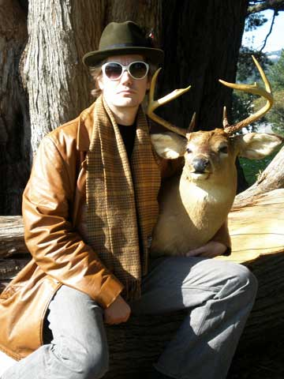
Deep Cuts
lives in Bernal Heights, San Francisco. He performs live sets around the Bay Area, and he studies music under Charlie Barreda and Jason Muscat. He is a founding member of Strangus, a collective of Bay Area recording and video artists. Deep Cuts is also a connoisseur and collector of fine colognes. Deep Cuts loves to collaborate with other artists. Please feel free to contact him though strangus.org.

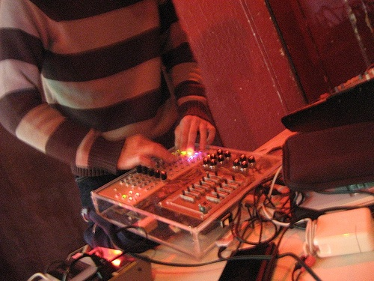
Evan Morris
programs nintedo ds music software, designs hardware midi interfaces, and has B.A. in Economics. He likes: kitty cats, unicorns, and magic rainbows. He dislikes: academic free improv, smarty pants, and snitches. www.lostscience.org/evanmorris

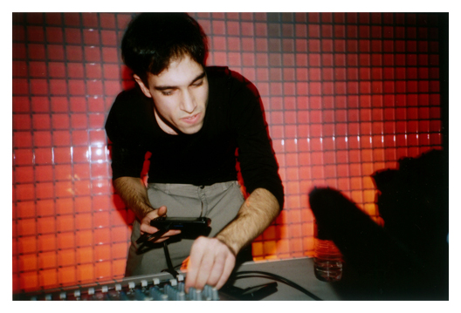
Starpause
Track bicycle fetishist and Creative Commons advocate, Jordan Gray
founded the Mp3Death netaudio label in 2004. M3D has since been
recognized by VORC and De:Bug for cataloging the sounds of handheld
techno and the chip tune avant-garde. K9D's own music fits somewhere
in between--body conscious beats and mind-melting basslines crafted on
pocket-sized consumer electronics. Blasting speakers with scene-built
software (LSDj & Piggy Tracker), STARPAUSE has represented at events
like BLIP FEST (New York City US), MICRODISKO (Stockholm, Sweden),
SPERM FEST (Prague, Czech Republic), and LAB30 (Augsburg, Germany).

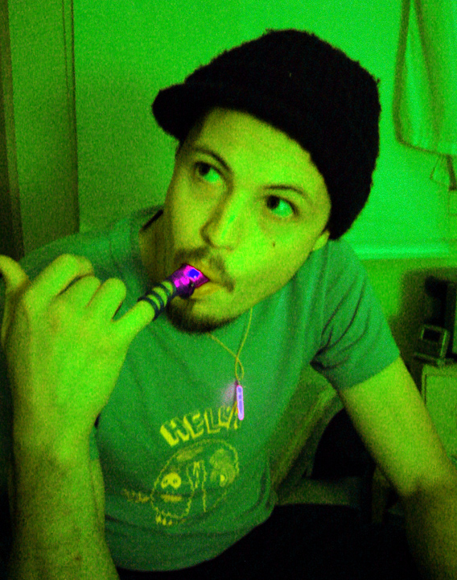
Kevin Shea Adams was born in Fairfax, CA and currently lives in Oakland, CA where he works as a freelance graphic artist. He is currently finishing his MFA at Mills College in the Electronic Music and Recording Arts program where he studies with Chris Brown, Les Stuck, Fred Frith and Zeena Parkins. A guitarist at heart, Kevin's background in music production and computer programming led him into electronica and electroacoustic music (Simplex5, Monday, WaveRunner, VRIKSHA). You can hear more at myspace.com/kevinsheaadams.

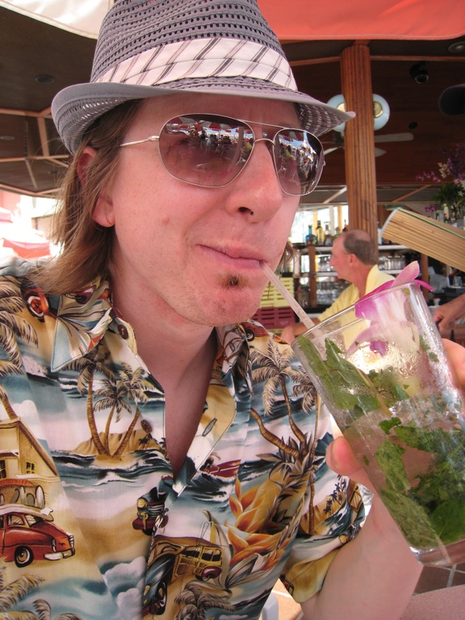
D-Rex is an alter-ego of Dallas Kashuba, and musician, producer and DJ based in San Francisco. He has been djing and producing music for 12 years, with a style at the meeting point of downtempo, spacey breakbeat, ambient electronica, and the softer side of drum and bass . He came out of the Los Angeles drum and bass scene of the late 90s and early 00s djing with a collective called Planet 9, who were behind the influential Midnite Bombers events. Dallas Kashuba is also one part of electronica group, Submodern, who have been producing music and performing live for 8 years.
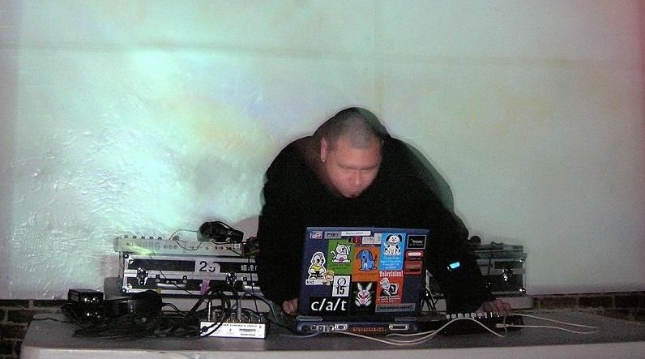
"Whormongr" is a solo musical project of wolfgang chan
(renamed circa 2003 - formerly known as rakpointzero)
which strives to find a common ground between rhythm,
noize, glitch and melody. Other occurances of the
rearing of wolf's ugly head include numerous DJ
residencies, side project "slither syndicate" (with
dre' of "nihil communication") and formerly of "seven
lies about girls" and "saint of killers".

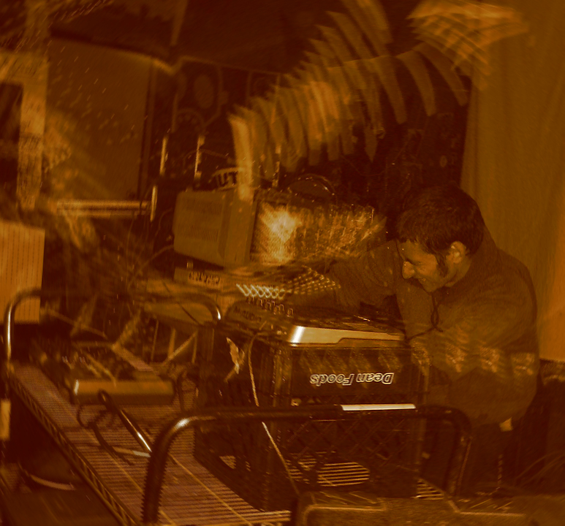
Jasper Reeder (AKA build128, nails, fivenotsix, etc...) has been sharpening his teeth over the last few years on warehouse crowds, dancefloors and various clubs around the bay area. A self proclaimed sound molester, build128 performs genre bending live sets ranging spanning from droning ambient monstrosities to high speed rave-core abominations. With deep rooted hip-hop and punk influences Jasper specializes in making aggresive, hyper melodic music with deep atmospheres and snarling sound design.

