
Artist: Dopestyle
Title: “The Little Happy/Fool’s Pool”
Format: Double-Album CD:
Label: Daly City Records
Catalog No: DCR-122
Release Date: 10/02/2007

Track Listing:
1ST disc “The Little Happy”
1.The Little Intro
2.Welcome My Friends
3.We Put It Down (feat. Pro the Leader, Opio f/ Souls of Mischief/Hieroglyphics)
4.Wrap It Around Me
5.Dominator D (Me & You)
6.Halogen (Song for Jacob)
7.Wake Up In the Morning
8.Patty Cake
9.Situations
10.Sleepless Babes
11.Stress Reducer
12.The Little Happy
13.The Last Party (Old Man Blues)
14.The Little Outro

2nd disc “Fool’s Pool”
1.Baby, Baby, Baby
2.The Bald Head Brute & The Long Hair Laymen (feat. Motion Man)
3.Drunk Phunk
4.Power of the P
5.Here It Is…Herpes (Johnny’s Story)
6.Thrillers N Killers
7.Peekaboo
8.Yellow Jello (Crack Cocaine Blues)
9.No Hope (Fool’s Pool part 1)
10.I’m A Big Fan of Yours
12.Riding Shotgun (feat. Fathed, 4am)
13.Without You (I’m Only A Loser)
13.When I Die (Fool’s Pool)
14.Untitled
BONUS TRACKS
15.Mr. Malaise & Friends (feat. Human Beings and Casual of Hieroglyphics) MOCHIPET REMIX
16. We Put It Down (feat. Pro the Leader, and Opio of Hieroglyphics) YOKO SOLO REMIX

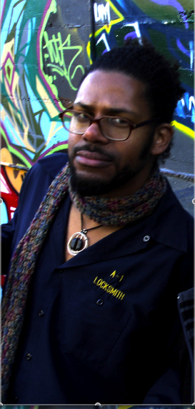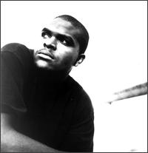
Dopestyle / Casual / Opio / Motion man

The first album, “The Little Happy” combines mid-1990’s ‘Golden Age’ era Hip-Hop meets Shoegazer fuzz & melodic Low rider classic R&B oldies with crackling Lo-Fi sensibilities into an intoxicatingly refreshing & effortlessly engaging sound tapestry. Both albums are produced in their entirety by Deejay 4am, whose expansive audio sound coloring & fluid texturing create emotively moving & daydream-ish atmospherics. Add to this the charismatic & quirky Emcee Dopestyle’s playful, insightful, and always provocative words & observations on life, relationships, & immortality…you get a soundtrack for persevering and staying ever hopeful & optimistic throughout life’s ups & downs. The album starts off on a celebratory note on songs such as “Welcome My Friends” & the cameo highlight posse song, “We Put It Down” featuring Pro The Leader & Opio f/ Souls of Mischief/Hieroglyphics. But by mid-album a melancholy gradually sets in on songs such as “Halogen (Jacob’s Song), a song depicting in 1st person narrative the many hard trials experienced by the emcee’s longtime friend & one-time homeless associate, Jacob. On other songs such as “Sleepless Babes” the effects of incest on family members not directly touched by this crime is described in 3rd person narrative. Other songs along the way inject lightheartedness & even niavete on songs such as “Wake Up In The Morning,” a song focusing on the rigors of living with Insomnia to “Stress Reducer,” a song on the calming effects associated with Marriquana. Then we come to the title theme song, “The Little Happy,” a song that deals with finding contentment in one’s life. Then the final song, “The Last Party (old man blues),” a song in 1st person narrative detailing the process of growing older as one looks back on his life, accepting his mistakes & decisions, and coming to full acceptance with an ever still hopeful eye & optimism making the conscious choice to die with dignity.
The recording for the second album, “Fool’s Pool” began shortly after the release of Kutmasta Kurt Presents Dopestyle 1231 in 2004. At this point in Dopestyle’s life, he was going through what could be described as a ‘mental break.’ This album reflects much of that challenging time for the emcee. As a self-described ‘Court Jester,’ Dopestyle is in rare form as he banters & hiccups luridly on songs such as “Drunk Phunk,” a total freestyle recorded while he was intoxicated that flawlessly segue to other songs such as “Here It Is Herpes…Johnny’s Story,” a song in 1st person narrative relaying the story of Dopestyle’s close friend & confidant, John. A song sparked at that time, by a recent STD scare Dopestyle experienced on his own. However on songs such as the Motion-Man assisted “The Bald Head Brute & The Long hair Laymen,” “Peekaboo,” “Thrillers & Killers,” and the Fathed assisted, “Riding Shotgun,” we see a balance between the urbane and the banter. Sonically, the less refined, raw reverberations helmed by Deejay 4am is nonetheless engaging & forward thinking in scope & execution.

