Daly City Records Presents: PU22L3 “Falling to Pieces”

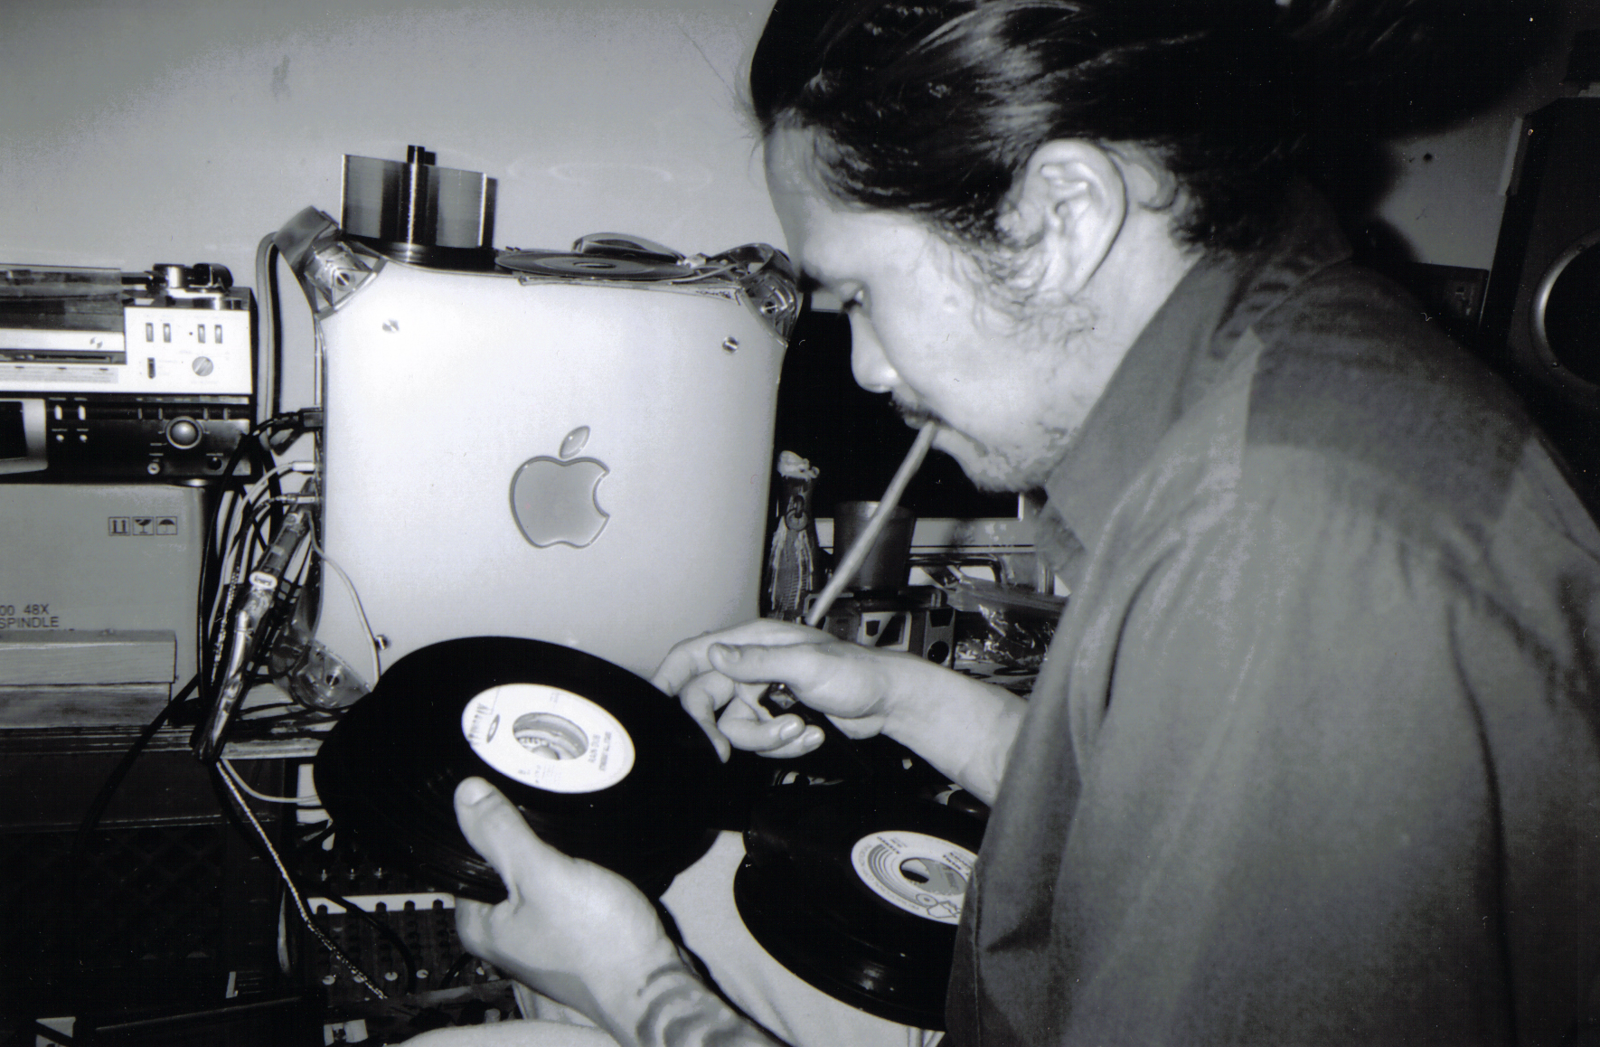

ARTIST: PU22L3
RELEASE DATE: 07/03/2007
TITLE: Falling to Pieces
LABEL: Daly City Records
CAT-NO: DCR120
FORMAT: CD
BARCODE: 6 20673 30962 2
His name is Pu22L3. puzzle if you're slow. custodial artist by day, bass bin killer by night. it was never always this harmonious. after failed attempts at bollywoodien porn under the sur name 'bahls mahal' , puzzle found an outlet for his blue balls touring and playing in thrash and metal bands. after everything burst, he decided to carve his niche within experimental music. local homeless refer to his music as "drugbient" because of how it induces vomiting and loose bowels after being heard. or maybe its the crack they freshly smoked. mpc in hand, his mission is to burn speaker cones and blow out sub woofers night after night. a drummer tapped inside a guitarist body, the drama of the two come out in every song. sweet, quiet, muppet loving, puzzle wants to give your mom a hug, lick your sisters ear, and steal every record out of your parents attics and basements. with a grin and blunt in hand, Pu22L3 puts it all together.
Tracklisting:
1) chased by tengu
2) i was born with arms and hands but no forearms, so its really hard to scratch my scrotum
3) i got paid $7.13 to drink my own pee (drugbient mix)
4) outside my bedroom when i was young
5) watching a rhino take a shit
6) we met at the art store
7) manstraiting
8) swam so deep i drowned
9) lets get the fuck outta here
10) i cant but help but notice the cankerous sore on your genitals (get your sexy on mix)
11) a mexican stand off with swords (wakizashi mix)
12) attempted underdose
13) dosed up beyond any recognition
14) RAVING TO PIECES (MOCHIPET REMIX)

